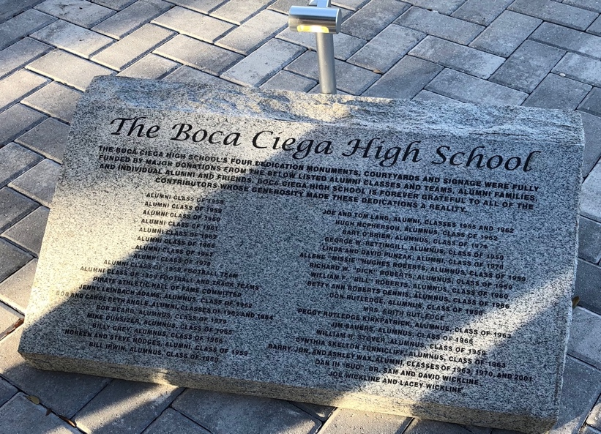

The Boca Ciega High School’s four dedication monuments and courtyards were fully funded by major donations from the below listed alumni classes and teams, alumni families, and individual alumnus and friends. Boca Ciega High School is forever grateful to all of the contributors whose generosity made these dedications a reality.

Alumni classes of 1958, 1959, 1960, 1961, 1962, 1967, 1978

Alumni class of 1958 Football Team

Alumni class of 1959 Football and Track Teams

Pirate Athletic Hall of Fame Committee

Jenni Leinbach Adams, Alumnus, class of 1962

Bob and Carol Beth Angle, Alumni, classes of 1962 and 1964

Bob Beard, Alumnus, class of 1979

Mike Dunsizer, Alumnus, class of 1965

Billy Grey, Alumnus, class of 1966

Noreen and Steve Hodges, Alumni, class of 1959

Bill Irwin, Alumnus, class of 1960

Joe and Tom Lang, Alumni, classes of 1955 and 1962

Hugh McPherson, Alumnus, class of 1962

Bart O’Brien, Alumni, class of 1974

George W. Pettingill, Alumnus, class of 1959

Linda and David Punzak, Alumni, class of 1978

Allene Missie Hughes Roberts, Alumnus, class of 1959

Richard W. Roberts, Alumnus, class of 1959

William F. Roberts, Alumnus, class of 1960

Betty Ann Roberts Dennis, Alumnus, class of 1966

Don Rutledge, Alumnus, class of 1958

Mrs. Edith Rutledge and Peggy Rutledge Kirkpatrick, Alumni, class of 1963

Jim Sauers, Alumnus, class of 1966

William H. Stover, Alumnus, class of 1959

Cynthia Skelton Tunnicliff, Alumnus, class of 1963

Barry, Jon, and Ashley Wax, Alumni, classes of 1963, 1990, and 2001

Joe Wickline

(print date April 18, 2018)